Service Broker Setup Notes for configuring Deptford baseline in vCloud

# Prerequisites

* Restore database from a previous baseline including the SSISDB on TS-DB2\INST1. SSISDB is only needed by some scripts to verify if SSIS exists, it then gets dropped.
* Copy SSB Certs and SSB Certs Pare Notifications folders to the D drive of the DB1 and DB2 – Certificates location $/Deployment/Main/Configuration/ServiceBrokerSetup
* Enable Service Broker on the following databases by right clicking properties -> Options ->Service broker -> Broker Enabled = True  
  TS-DB1\INST2.Pare   
  TS-DB2\INST2.PCS  
  TS-DB1\INST3.Notifications
* Run the scripts in the SQLCMD mode

In Source Control Explorer get the latest from $/Deployment/Main/Configuration/ServiceBrokerSetup/

In the DBDeploy folder you’d see six folders which contain all the scripts to configure service broker for a respective database.

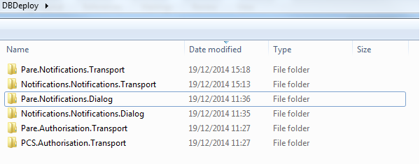

SSB Certs and SSB Certs Pare Notifications folders contains all the certificates needed.

# Configuration

### Configuring Pare.Authorisation.Transport

Open   
DBDeploy\Pare.Authorisation.Transport\Transport.Pare.sql   
&  
DBDeploy\Transport.Pare.Certs.sql

Make sure the variable path of the script and certificate location is pointing correctly

Run Transport.Pare.sql against the TS-DB1\INST2.Pare database

### Configuring Pcs.Authorisation.Transport

Open   
DBDeploy\Pcs.Authorisation.Transport\Transport.Pcs.sql   
&  
DBDeploy\Transport.Pcs.Certs.sql

Make sure the variable path of the script and certificate location is pointing correctly

Run Transport.Pcs.sql against the TS-DB2\INST2.Pcs database

### Configuring Pare.Notifications.Transport

Open   
DBDeploy\ Pare.Notifications.Transport\Transport\Transport.Pare.sql  
&  
DBDeploy\ Pare.Notifications.Transport\Transport\Transport.Pare.Certs.sql

Make sure the variable path of the script and certificate location is pointing correctly

Run Transport.Pare.sql against the TS-DB1\INST2.Pare database

### Configuring Pare.Notifications.Dialog

Open   
DBDeploy\ Pare.Notifications.Dialog\Dialog.Pare.sql  
&  
DBDeploy\ Pare.Notifications.Dialog\ Dialog.Pare.Certs.sql

Make sure the variable path of the script and certificate location is pointing correctly

Run Dialog.Pare.sql against the TS-DB1\INST2.Pare database

### Configuring Notifications.Notifications.Transport

Open   
DBDeploy\ Notifications.Notifications.Transport\Transport\Transport.Email.sql  
&  
DBDeploy\ Notifications.Notifications.Transport\Transport\Transport.Email.Certs.sql

Make sure the variable path of the script and certificate location is pointing correctly

Run Transport.Email.sql against the TS-DB1\INST3.Notifications

### Configuring Notifications.Notifications.Dialog

Open   
DBDeploy \Notifications.Notifications.Dialog\Dialog.Notifications.sql  
&  
DBDeploy\ \Notifications.Notifications.Dialog\Dialog.Notifications.Certs.sql

Make sure the variable path of the script and certificate location is pointing correctly

Run Dialog.Notifications.sql against the TS-DB1\INST3.Notifications

**Notes:**

If you’re receiving the error

An exception occurred while enqueueing a message in the target queue. Error: 15581 State: 7. Please create a master key in the database or open the master key in the session before performing this operation

To fix this you’d need to run this statement

alter master key add encryption by service master key